

NAC-AEP E-Services Portal
User Guide for Instructor Tagging (2026 Cycle)

Updated in October 2025

Contents

About Instructor Tagging for NAC-AEP....................................................................  Key Dates ……………………….…………………………………………….………………………………………………………. | 3  3
Before You Start ......................................................................................................................... | 4
Instructor Tagging Process  NAC-AEP Instructor Tagging (Providers)  - Login ………………………..…………………………………………………………………………………………………  - Tagging Registered Instructors to Programmes …..……………………………………………………..  - Removing/Withdrawing an Instructor ..………………………………………………………………………  - Viewing Instructor Response ..…………………………………………………………………………………….  NAC-AEP Instructor Tagging (Instructors)  - Login ………………………..…………………………………………………………………………………………………  - Accepting/Declining an Instructor ………………….…..……………………………………………………...  - Declining/Retracting an Accepted Instructor ..………………………………………......……………… | 5  6  8  9  10  11  12



About Instructor Tagging for NAC-AEP 2026 Cycle

Providers with approved 2026 National Arts Council-Arts Education Programme (NAC-AEP) are required to tag registered instructors in the NAC-AEP E-services Portal to their respective approved 2026 programmes.

Prior to this Instructor Tagging phase, providers would have informed instructors to register and submit portfolios in preparation for tagging to their approved programmes.

Registered instructors may accept/reject the tagging requests accordingly.

This document will guide providers in tagging registered instructors to their approved programmes, as well as for registered instructors to respond to tagging requests.

Key Dates

November 2025 | Notification of Successful Applications and Onboarding of Instructors Upon NAC’s notification to all providers of the status of their NAC-AEP applications, providers with approved programmes will then inform the instructors who have been identified to teach the approved programmes to register in NAC-AEP E-services Portal.  Providers are responsible for engaging instructors who fulfil the art form expertise, teaching experience and pedagogy training requirements as stated under Instructor Credentials in the Assessment Criteria to conduct the approved programmes. Providers will subsequently tag the relevant registered instructors to their approved programmes.
December 2025 | Notification of Final Results  Programmes with approved content and minimum number of instructors required to conduct the programme will be published on the NAC-AEP Directory.

Before You Start

Important Information
- Instructors will need to register directly on NAC-AEP E- services Portal to be eligible to conduct NAC-AEP in schools.
- The Instructor Tagging process comprises 2 parts: 1) Providers will search and tag the identified registered instructor(s) to each approved programme; and 2) Instructor will need to accept or decline the tagging to each approved programme.
- Providers are responsible for engaging instructors who fulfil the art form expertise, teaching experience and pedagogy training requirements as stated under Instructor Credentials in the Assessment Criteria to conduct the approved programmes.
- Instructors are responsible for informing their providers of their registered name and /or alias on NAC-AEP E-services Portal upon notification of successful Instructor Registration so that that providers can start tagging.
- Please read our Privacy Statement for NAC's data management policy.

To note before tagging instructors
- Providers should have:
  - Informed their identified instructors to complete Instructor Registration on NAC-AEP E- services Portal.
  - Asked registered instructors for their registered name and/or alias on NAC-AEP E- services Portal to ensure easy search during tagging.
  - Accepted all the Terms and Conditions of NAC-AEP.

- Providers can opt to save and continue working on your draft instructor tagging at a later time by clicking the ‘Save and Exit’ button.
- Providers should review the instructor tagged to each approved programme before clicking
the ‘Submit’ button. Draft instructor tagging will not be considered as submitted.

NAC-AEP Instructor Tagging (Providers)

Logging in
- Navigate to NAC-AEP Directory website and click on the ‘Login’ menu at the top right corner.

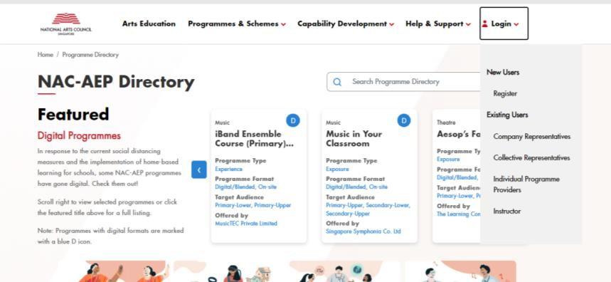

Fig.1 NAC-AEP Directory Login
- Click on any of the appropriate options under ‘Existing Users’, e.g. ‘Company

Representatives/ Collective Representatives/ Individual Programme Providers’.

- Log in with Singpass

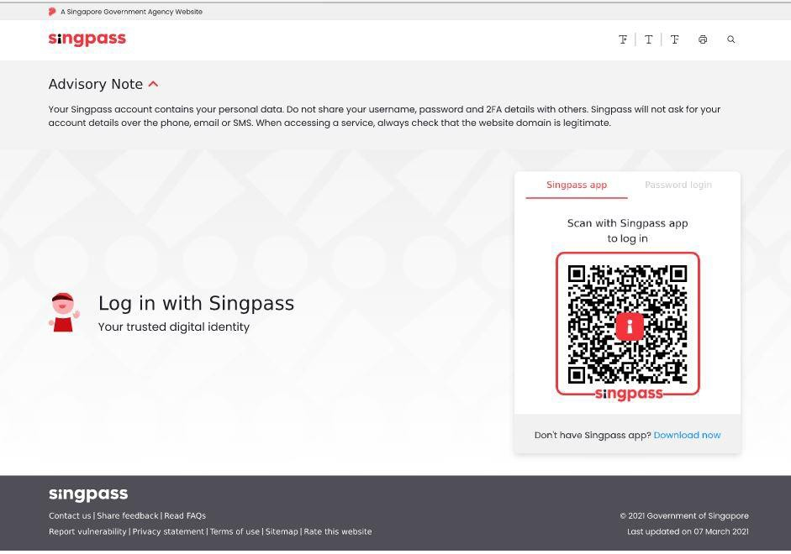
Fig. 2 Log in with Singpass Page
- After a successful log in, you will be brought to your Provider’s Overview page.

Tagging registered instructors to programmes
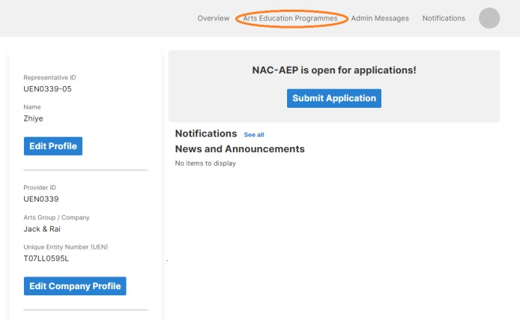
Fig. 3 Provider’s Overview page

- Click on ‘Arts Education Programmes’ on the navigation bar. You will be brought to the Dashboard.

- Click on ‘2026 - 2028’ Cycle. Look for your ‘Pending Instructor’ programme and click on the relevant programme card’s kebab menu (three dots) to select ‘Add Instructor’ to begin.

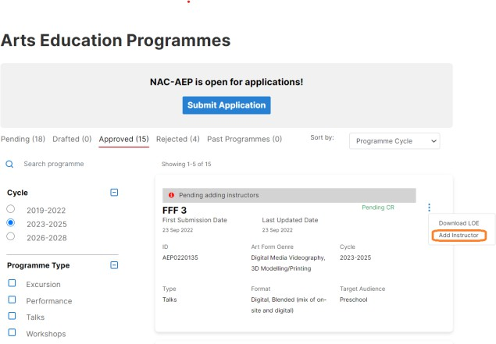

Fig. 4 Dashboard

You will then see the ‘Instructor tagging page’. There are 2 sections on this page, ‘Favourited’ and ‘Recent instructors’, as well as a search bar. No instructors will be shown unless you have either indicated the instructor as a Favourite or started tagging instructors to programmes.
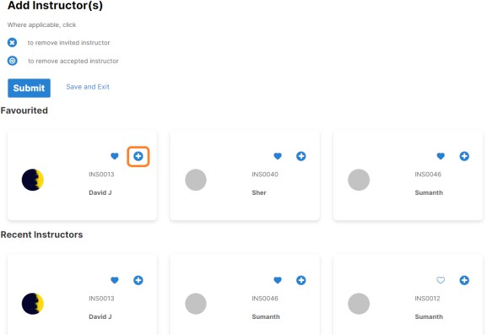

Fig. 5 Instructor Tagging Page

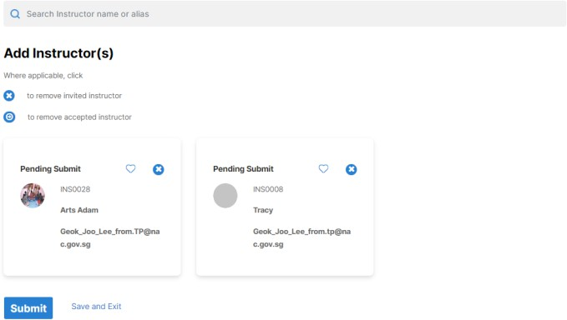
Fig. 6 Search Bar

- Search for the identified instructor by entering their name into the search bar.

- Once an instructor card appears, click on the ‘+’ icon of the instructor card to add the
instructor. You may also click on the ‘heart’ icon to add them to your favourites.

- Once you have added the minimum number of instructors required for the programme, click
on ‘Submit’. Clicking on ‘Save and Exit’ will save your progress as a draft.
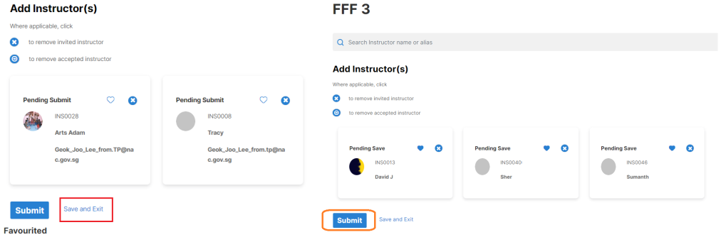
Fig. 7 and 8 Save and Exit; Submit


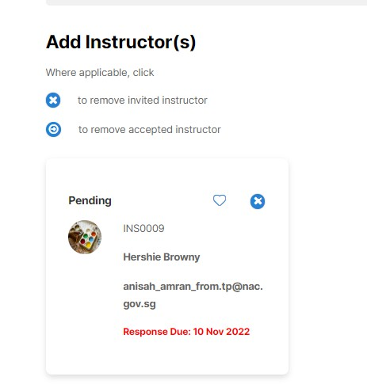
Once you have submitted, you will see a ‘Response Due’ date on the instructor card along with the status ‘Pending’. Please wait for the instructor to accept or decline your request.
Response due: 10 Nov 2025
filler@email.com
Fig. 9 Pending instructor response

Removing/Withdrawing an Instructor

To remove an instructor from your programme, click on the relevant programme card’s kebab menu (three dots) to select ‘Add Instructor’. Take note that you may remove an invited instructor ( icon) or an instructor who has already accepted ( icon)

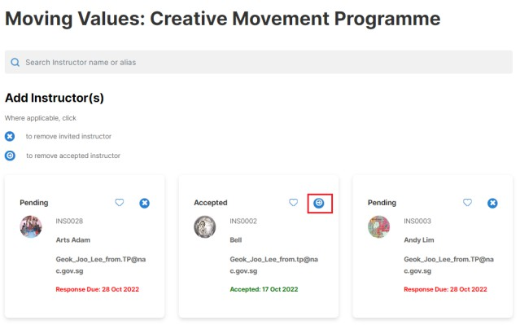
Fig. 10 Removing Instructors

  - After clicking on the icon, you will be prompted with a Confirmation Pop-up. Click ‘Proceed’
to confirm the removal.

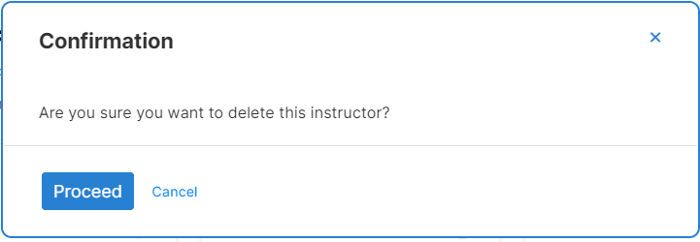
Fig. 11 Confirmation of Removal

Viewing Instructor Response
  - Go to the Dashboard to view Instructor’s response.
  - Navigate to ‘Arts Education Programmes’ page and select 2026 cycle.
  - Select a programme with added instructor(s) and click on the programme card.
  - Click on Instructor Tab to see tagged instructors and their responses.
Note: If provider and instructor are the same user, remember to Logout of instructor account before logging in to Provider account to avoid binding 2 internet sessions.

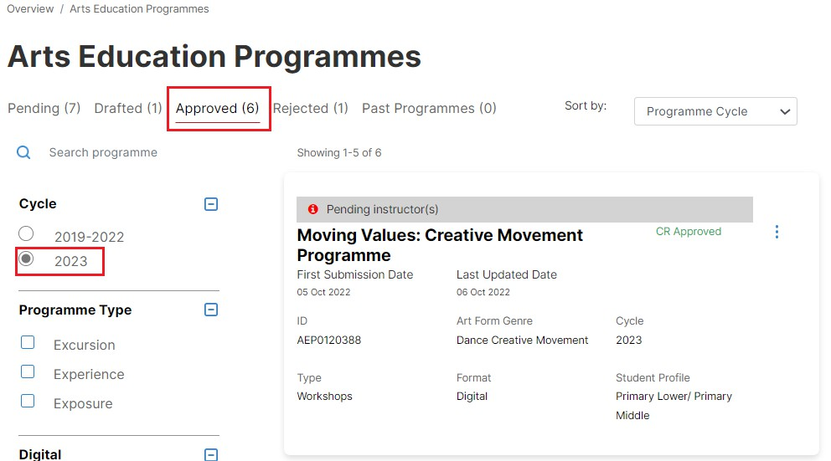
2026
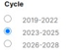
Fig. 12 Dashboard

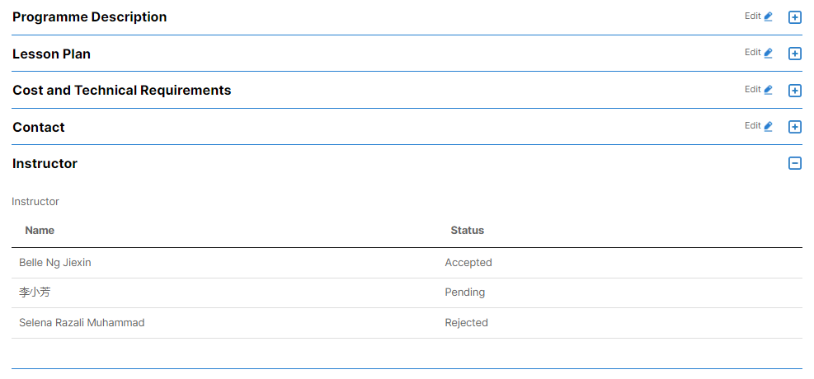
Fig. 13 Checking of Instructor Responses.

NAC-AEP Instructor Tagging (Instructors)

Login
  - Navigate to NAC-AEP Directory website and click on the ‘Login’ menu at the top right corner.

Fig.14 NAC-AEP Directory Login
  - Click on ‘Instructors’ under existing users if you have already registered an instructor account. Otherwise, please refer to User Guide for Instructor Registration for the steps to do so.
  - Log in with Singpass

Fig. 15 Log in with Singpass Page

Accepting / Declining an Invitation

  - Once logged in, you will be brought to the Instructor Dashboard.

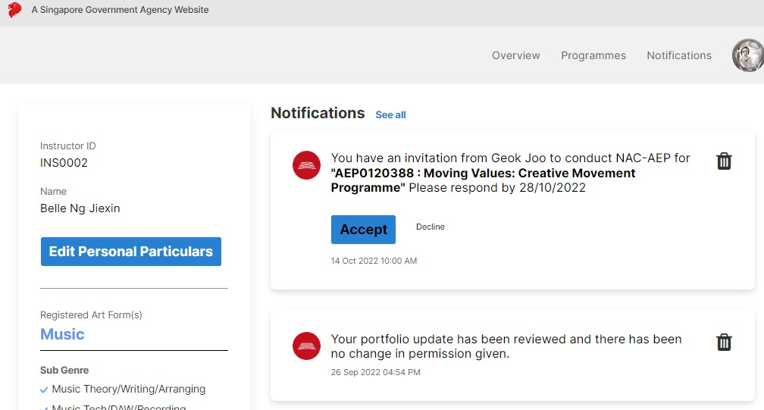
Fig. 16 Instructor Dashboard
  - You will see the tagging request under ‘Notifications’. Click ‘Accept’ or ‘Decline’ on the dashboard notification to accept or decline Provider’s invitation.

  - Alternatively, you may accept or decline invitations by navigating to the ‘Programmes’ page and select the ‘Pending Programmes’ tab.

Click on the programme card to view tagged programme details.

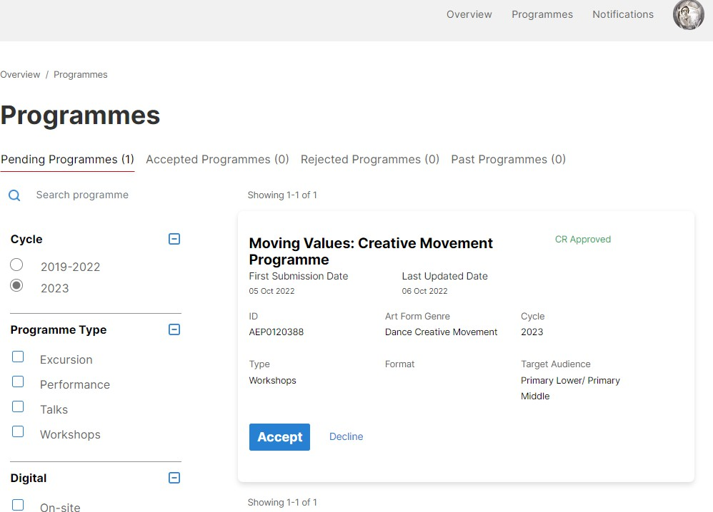
2026
Fig. 17 Tagged Programme Details

Declining/Retracting an Accepted Invitation

  - Select the ‘Accepted Programmes’ tab. Click the checkbox found above programme title on
the programme card.

  - To Decline, Click ‘Move to Rejected’ button.
  - To Retract an accepted invitation, click ‘Move to Pending’.

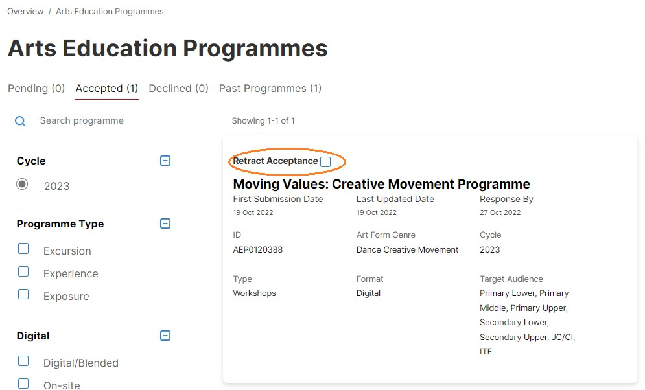
2026
Fig. 18 Checkbox on programme card


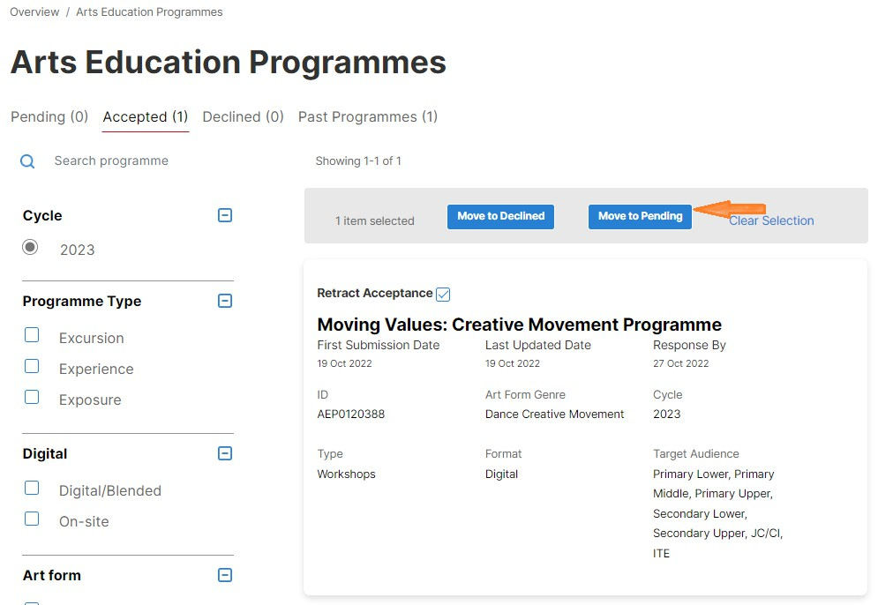
2026
Fig. 19 Respective buttons for Decline/Retract

Note: Instructor cannot undo a ‘Declined’ invitation. If the instructor erroneously declined an invitation, he/she will have to request the provider to re-send the invitation.

